Benefits of bowling
Strengthen muscles:
Bowling is an exercise that strengthens the growth of muscles in your legs and arms. It also improves your flexibility.
Gets those steps in:
The average bowler will walk about 1500 steps in a three game set!
Social aspect:
Bowling is a team sport, it is a great way to build relationships and create friendships with folks that share a similar interest with you.
Helps relieve stress:
Bowling engages us in physical activity, which can help improve mental health by reducing anxiety, depression, and negative mood and by improving self-esteem and cognitive function.

 |  |  |  | 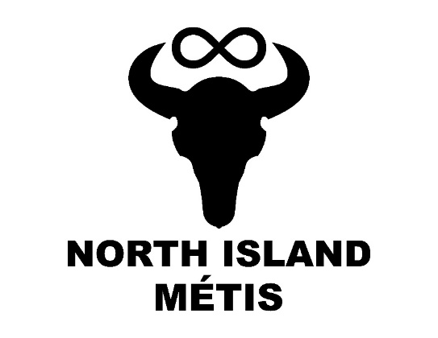
 |  |  | Funding for this program provided by Island Health’s Indigenous Health Initiative Program (IHIP) 2022-2023 | 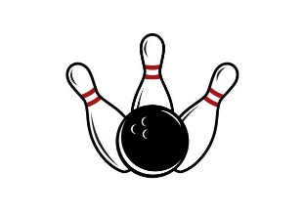  BOWLING
A124 – 740 Robron Road
Campbell River, BC V9W 6J7
250-287-7417
www.nimetis.com
North Island Métis (NIMA) publishes a monthly newsletter.
Go to NIMA’s website (www.nimetis.com/newsletters) to read current and past newsletters.
FOLLOW NIMA ON SOCIAL MEDIA:
Facebook @northislandmetisassociation
Instagram
@northislandmetis @youthnima
YouTube
North Island Métis

 | métis Teamwork  The Tradition Métis Laws of the Buffalo Hunt Include:  - No buffalo to be run on the Sabbath-Day.  - No party to fork off, lag behind, or go before without permission.  - No person or party to run buffalo before the general order.  - Every captain with his men, in turn, to patrol the camp, and keep guard.  - For the first trespass against these laws, the offender to have his saddle and bridle cut up.  - For the second offence, the coat be taken off the offender’s back and be cut up.  - For the third offence, the offender to be flogged.  - Any person convicted of theft, even to the value of a sinew, to be brought to the middle of the camp, and the crier to call out his or her name three times, adding the word “Thief,” at each time.  According to Christopher Adams, though the laws allowed leaders to organize the hunt, it also allowed them “to oversee the stewardship of the land and resources derived from it”. |  | Southern Michif  Ball – la plot  Team – aen chim  Teammate – aen naasasyi  Teamwork – ka niisho atooshkayhk  Fun – mochikihtow  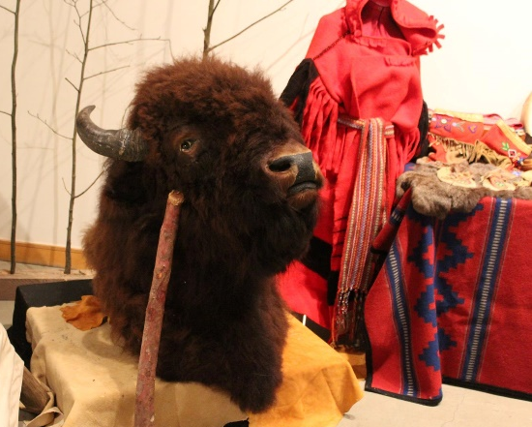  Friend – aen naamii  November 2022 |  | 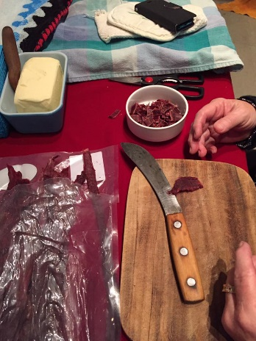

pemmican recipe

2 lbs. of lean buffalo or beef
1/4 cup dried berries
5 tablespoons of animal fat

Cut the meat into long strips and hang in the sun to dry for several days or dry by a fire. When completely dry, pound each strip until broken into flakes then mix together the flakes and dried berries. The meat, berries and melted fat can be mixed into a bowl. When the fat has cooled the ingredients can be rolled into large balls, or made into a hard block and cut into pieces, and stored in plastic bags. Pemmican can be eaten as is, cooked like hamburger, or boiled with flour and water to make soup.
(https://www.louisrielinstitute.com/87-food/)

