benefits of foraging
“There is significant evidence that outdoor activity contributes even further to improved mental health by connecting us to our natural environment. Activities on the land can provide opportunities for land-based Métis practices such as hunting, fishing, gathering food and medicine, and crafts. Physical activity and connecting to the land are also a way for families to engage with the Métis Core Values which “guide us to live a meaningful and balanced life”. Métis Core Values: Mother Earth, Patience, Strength, Kindness, Tolerance, Honesty, Respect, Love, Sharing, Caring, Courage and Creator.” (Learn with Louis Newsletter)
North Island Métis (NIMA) publishes a monthly newsletter.
Go to NIMA’s website (www.nimetis.com/newsletters) to read current and past newsletters.
FOLLOW NIMA ON SOCIAL MEDIA:
Facebook @northislandmetisassociation
Instagram @northislandmetis @youthnima
YouTube
North Island Métis
FUNDING FOR THIS PROGRAM
PROVIDED BY INDIGINOUS HEALTH INITIATIVE PROGRAM
October 2022

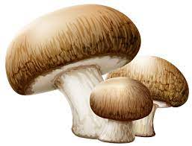
Mushroom Foraging
and Harvesting
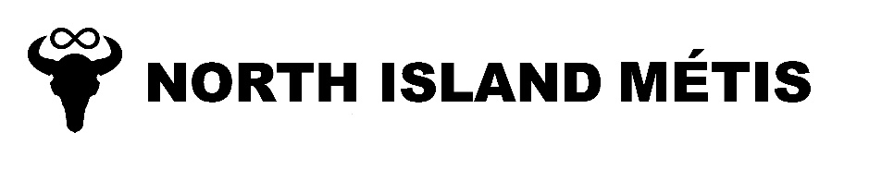
A124 – 740 Robron Road
Campbell River, BC V9W 6J7
250-287-7417
www.nimetis.com

 | Harvesting tips  - When harvesting morel mushrooms, cut the stem above the ground. Do not pull or tear the mushroom out of the ground. This leaves the dirt in the forest instead of transferring the dirt to your collecting container  - Do not disturb the soil surface, since doing so can harm the mycelium (the underground, thread-like network that produces the mushrooms)  - Only pick mushrooms that you will actually use. Broken and over mature morels may continue to spread their reproductive spores if they’re left untouched  - Confirm the mushroom’s identity with an experienced harvester, buyer or biologist – some mushrooms need to be cooked well or dried before you can safely eat and we do have poisonous mushrooms in BC.  - Harvesting is allowed on provincial crown land, but it is against the law to harvest in provincial parks and permission must be given on private property. |  | southern michif  Mushroom – lii mushroom  Harvest – pawahikayhk  Forest – li graan bwaa  Mountain – enn moontaayng  Hike – pamohtaywin  Let’s go for a walk – enn walk ka ootinaynaan
 |  |  |  |  | Edible mushrooms contain substantial amounts of B vitamins, copper, protein, potassium, choline, vitamin D, selenium, fiber, phosphorous, niacin, folate, amino acids and antioxidants. Some mushrooms even contain significant amounts of protein!

