 | benefits of geocaching |  | North Island Métis (NIMA) publishes a monthly newsletter.  Go to NIMA’s website (www.nimetis.com/newsletters) to read current and past newsletters.  FOLLOW NIMA ON SOCIAL MEDIA:  Facebook @northislandmetisassociation  Instagram @northislandmetis @youthnima  YouTube  North Island Métis  FUNDING FOR THIS PROGRAM  PROVIDED BY INDIGINOUS HEALTH INITIATIVE PROGRAM  October 2022
Decreases stress  Being outdoors, in nature, encourages you to relax and distress, which helps to reduce your risks of becoming ill.  Boosts your mood  Participating in a physical activity that you enjoy boosts the chemical hormones in your brain that improve your mood and will also help you to sleep better at night.  Sharpens your skills  Studies have shown that keeping the mind challenged with activities like puzzles and problem solving can lead to a longer life expectancy, better quality of life, and increase our overall health.  Makes you stronger  Aside from the endorphins, weight loss, and increased energy that come from working up a sweat, geocaching makes you stronger in other ways too. Overcoming fears and obstacles increases your brain’s idea of what you are capable of. |  |  |  |  | 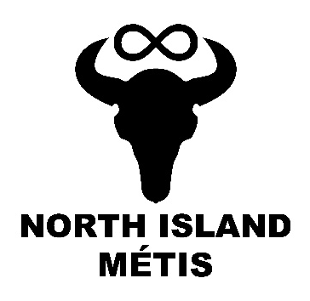
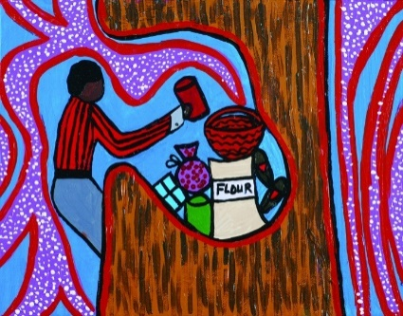
Geocaching
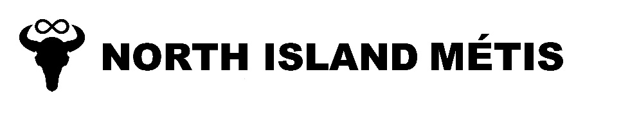
A124 – 740 Robron Road
Campbell River, BC V9W 6J7
250-287-7417
www.nimetis.com
Modern day geocaching has a very similar feel to the traditional Métis story of The Giving Tree. A wonderful story about a tree with a hollowed out hole that people would leave extra items to share with other travelers who may have forgotten something. People would take only what they needed and leave something in return. The story emphasizes the Métis core values and beliefs including strength, kindness, courage, tolerance, honesty, respect, love, sharing, caring, balance, patience, and most of all, the important connection with the creator and Mother Earth.  The giving tree |  |  | southern michif
 |  |  | The giving tree – Laarbr kawmaekit  search for – Natoona  Hide – kaashoo  Walk – pimohtew  forest – li graan bwaa  Trade - mayshkootoona |  | 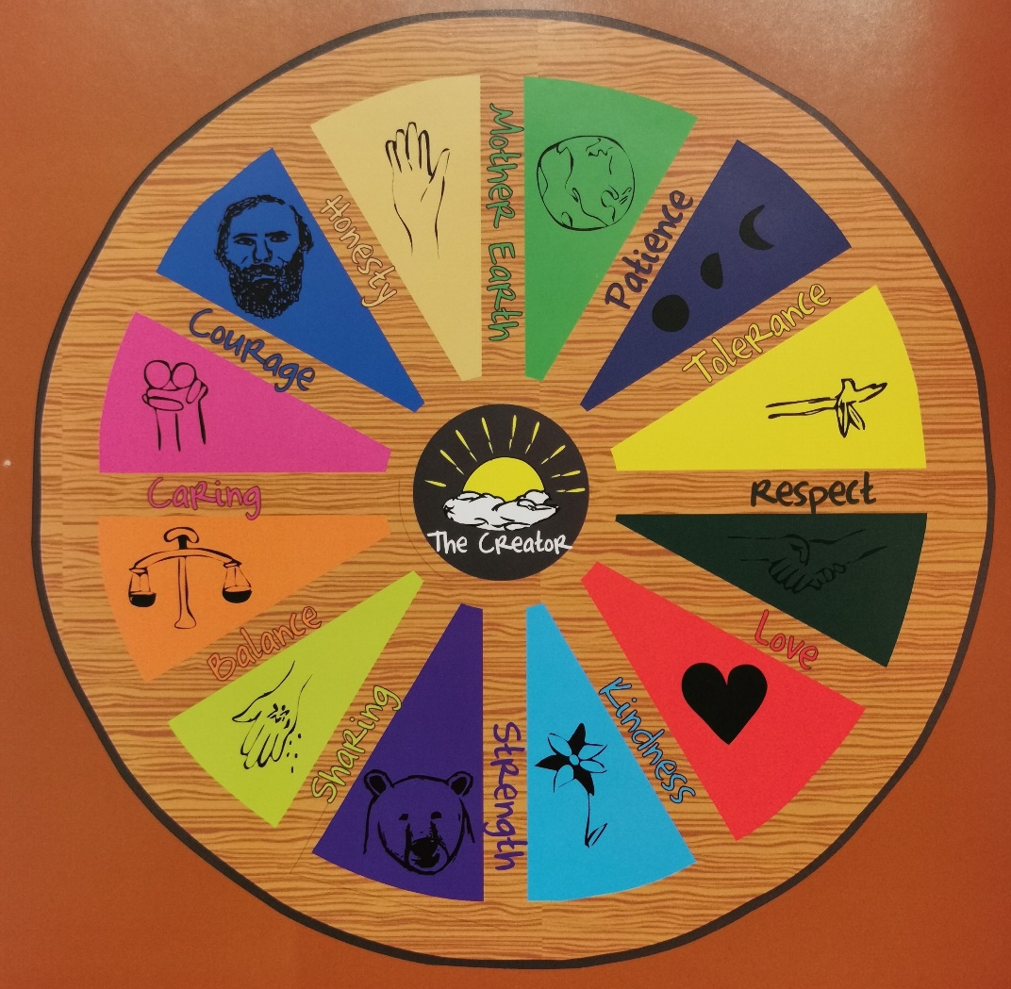  Traditional Métis Values:  Creator  Mother Earth  Honesty  Courage  Caring  Balance  Sharing  Strength  Kindness  Love  Respect  Tolerance  Patience
