 | benefits of golf  - Reduces stress due to physical activity and the joy of being close to nature  - Improves social interactions by bringing together people who have a shared interest and to connect with friends  - Helps you retain a sense of achievement by becoming better at something that you enjoy doing  - Actively engages your body and mind  - Swinging your club engages your core and upper body muscles  - Golfing regularly helps to improve your balance  - Improves blood circulation  - Playing regularly helps to improve lung function and reduce risk factors for cardiovascular disease  - Helps you get those 10,000 steps in! |  | North Island Métis (NIMA) publishes a monthly newsletter.  Go to NIMA’s website (www.nimetis.com/newsletters) to read current and past newsletters.  FOLLOW NIMA ON SOCIAL MEDIA:  Facebook @northislandmetisassociation  Instagram  @northislandmetis @youthnima  YouTube  North Island Métis
 |  |  | Street Address  Funding for this program provided by Island Health’s Indigenous Health Initiative Program (IHIP) 2022-2023  Phone Number  Website | 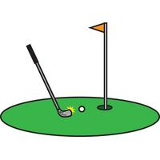  Golfing
A124 – 740 Robron Road
Campbell River, BC V9W 6J7
250-287-7417
www.nimetis.com

 | voyageur games  Here is a list of a few commonly played voyageur games!  Leg Wrestling: Two competitors lay side by side on the ground with heads beside each other’s feet. They then locked one leg and tried to knock their opponent over.  Voyageur Wrestling: This match involved both combatants facing each other, grabbing one hand as if in a hand shake, then trying to make their adversary lose their balance. Once your foot lifted off the ground, you lost.  Pillow Fight: Using massive pillows/large canvas stuffed bags to try to knock the opponent off of a 6″ x 6″ beam.  Tug-of-War: Players stood on barrels about 15 feet apart from each other holding a rope. The object of this game was to either pull your opponent off the barrel or to pull the rope out of their hands.  Log Sawing: Participants see who can saw through their log first.  Flour Sack Races: Participants would race to see who could get the finish line first, while carrying a sack of flour.  Axe Throwing: Participants would take turns throwing axes at a target to see who could get the closest to the bullseye.  Sling Shot: Pop cans are used as targets and each contestant is allowed five shots. |  | Southern michif  stick – aen bwaa  ball – la plot  axe – enn haash  wrestle – la kwaalty  saw log – enn log a syii  to race - kootshkaawayhk  November 2022 |  | 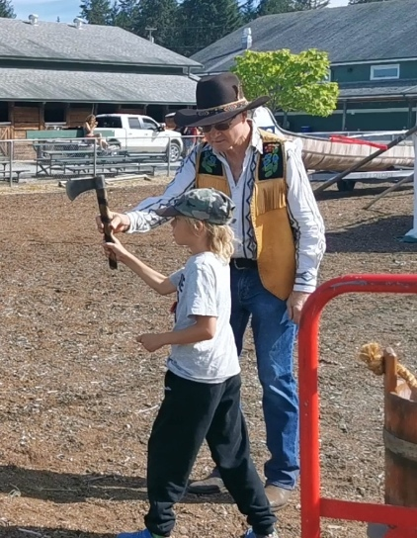

About the games
Métis people were well-known for being competitive, whether it be through their story telling or their strength they would compete to see who was the strongest. The games were created to test the strength and endurance of the voyageurs. The games date back to the fur trade era (1700’s and 1800’s). The games would test the voyageurs to see who was the ultimate voyageur! The games were used to bring folks together and were often paired with music, dancing and food.

