BEnefits of cardio
Here’s what cardio does for your health:
- Gets your blood pumping
- Lowers your blood pressure
- Strengthens your immune system
- Helps to improve your sleep
- Improves your mental health
- Helps to regulate blood sugar
- Contributes to a healthy weight
- Boosts your brain power
North Island Métis (NIMA) publishes a monthly newsletter.
Go to NIMA’s website (www.nimetis.com/newsletters) to read current and past newsletters.
FOLLOW NIMA ON SOCIAL MEDIA:
Facebook @northislandmetisassociation
Instagram @northislandmetis @youthnima
YouTube
North Island Métis
FUNDING FOR THIS PROGRAM
PROVIDED BY INDIGINOUS HEALTH INITIATIVE PROGRAM
October 2022
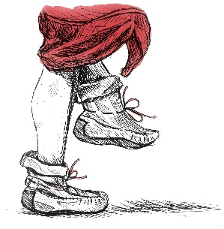
Jigging
A124 – 740 Robron Road
Campbell River, BC V9W 6J7
250-287-7417
www.nimetis.com

 | History  The Métis people are well-known for their love of music and dance. Originating in the Red River area, Métis jigging is believed to have started in the mid-1800s. The first recorded reference to the Red River Jig was in 1860 and today it is played at almost all Métis gatherings. A couple of the other more popular dances include the Broom Dance and the Sash Dance.  The Métis jig is a combination of First Nations dancing, Scottish and French-Canadian step-dancing. The "Red River Jig", or as it is known in Michif, "oayache mannin," is the most famous Métis dance. This jig is a special fiddle tune that is played at almost all Métis functions and is danced in two parts. In the first part, a traditional jig step is performed while the fiddle plays a high section, then the fiddle switches to a lower section, and the second fancy footwork part of the dance is performed. Métis fiddle music is known as crooked music, which means that the number of bars or beats of music is different than what’s expected or customary. |  | southern michif  Fiddle – aen vyayloon  Red River Jig – oayache mannin  Family – faamii  Friend – aen naamii  Kitchen Party – aen party di chwiizinn  Sash – sayncheur flayshii |  | 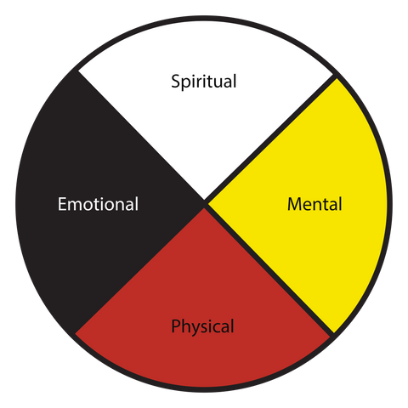
Jigging provides the extra added bonus of creating a sense of community, culture and connection.

The University of Saskatchewan is currently undergoing a three-year study to look at the health benefits of jigging versus other forms of cardio!

