 | benefits of swimming  The Centre for Disease Control has on their website some of the benefits of swimming are:  Arthritis  Water-based exercise can help people with arthritis improve the use of their arthritic joints without worsening symptoms. People with rheumatoid arthritis have shown more health improvements after swimming in warm water than with other activities. Water-based exercise can also improve the use of affected joints and decrease pain from osteoarthritis.  Mental Health  Swimming can improve mood in both men and women. For people with fibromyalgia, swimming can decrease anxiety, and exercise therapy in warm water can decrease depression and improve mood.  Older Adults  Water-based exercise can benefit older adults by improving their quality of life and decreasing disability. It can also improve or help maintain the bone health of post-menopausal women.  Water-based Exercise Can Benefit Everyone  Exercising in water offers many physical and mental health benefits and is a good choice for anyone who wants to be more active. |  | North Island Métis (NIMA) publishes a monthly newsletter.  Go to NIMA’s website (www.nimetis.com/newsletters) to read current and past newsletters.  FOLLOW NIMA ON SOCIAL MEDIA:  Facebook @northislandmetisassociation  Instagram  @northislandmetis @youthnima  YouTube  North Island Métis
 |  |  |  | 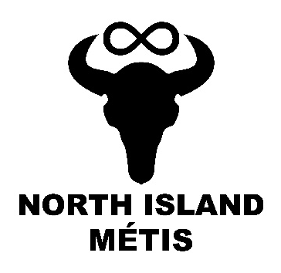
 |  |  | Street Address  City, St Zip Code.  Funding for this program provided by Island Health’s Indigenous Health Initiative Program (IHIP) 2022-2023  Website | Swimming
A124 – 740 Robron Road
Campbell River, BC V9W 6J7
250-287-7417
www.nimetis.com

 | York boat  The York Boats, named after York Factory, were built by Métis working for William Sinclair. York Boats date back to as early as 1746. The York Boats quickly replaced canoes, due to the fact that they could carry a much higher weight limit – this meant more money. The boats were able to carry more than three times the amount of weight (up to 6000lbs) while still requiring the same number of crew members. Originally the boats started out at 13 meters in length, but they did end up with three different sized vessels as time went on. The crew consisted of six rowers, a helmsman (who called out instructions) and someone who steered the boat. For long voyages from the south, each boat would carry one specific item. The boats would then travel together as one large convoy on their way back to their settlement. |  | southern michif  Swimming – pimaatakaak  Water – di loo  Fun – mochikihtow  Splash – kwaashkwaypinamihk diloo  Exercise – shayshaawii  Fur – li pwel daanimoo  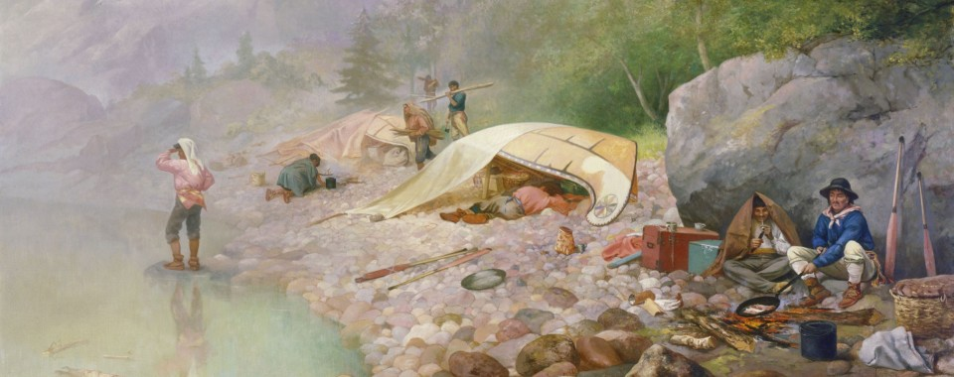  sing - nakamoo |  | 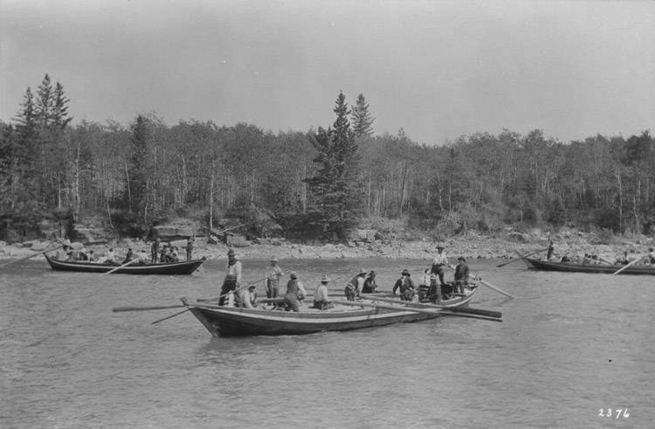

Voyageur facts
- Voyageurs would travel for 16 hours a day
- They would often trek 3,600km over 70-85 days
- Portaging a York Boat would require the use of log rollers going over rocks, through swamps and up 350 metre inclines
- Voyageurs would sing all day to keep pace with their paddling
- Drowning was common, along with broken limbs, compressed spine, hernias, and rheumatism.
- Time would be measured by the number of songs sung and pipe breaks, where they would stop paddling every hour or so for a couple minutes to smoke a pipe.
- Voyageurs were expected to be able to carry a minimum of two 90lb bundles at a time, some could carry up to seven!
November 2022

